This is a new study composed of two PowerPoint presentations, covering Scripture from Creation to just past the calling of Abram from the city of UR. Also included is the Tower of Babel episode and the interpretations associated with the displacement of those people. This study is designed for clergy and lay instructors to use in teaching Genesis apologetics to the Jr. high and up, plus adult age groups. Instructor notes are provided which can also be used for self-study sessions. Instead of solely presenting individual topics there is an attempt to connect some of the dots between topics.
It does contain some scientific analysis but does not get too far into the “weeds” on any topic. There is extensive use of links where the instructor or student may search for more detailed information on scientific or complex points. Each part consists of 5 to 6 hours of presentation, with a little humor now and then to make a point or expose another way to look at the issue. Once you get started with this experience you will want to continue to explore new thoughts while getting a fuller understanding of the importance of Genesis and the concept of a young earth created in six 24-hour days, or more precisely, six complete rotations of the earth on its axis.
Part I. This part contains the following sections: Citations, Media on the Origins of Lutheran Creationists, Why This Presentation, Introduction, Which World View are You Using? Which Lens are You Using? The Days of Creation, The Perfect World, The Temptation, The Fall & the Fall Story Continues, Period Summary, What the Atheist World Believes, Counterpoints, The Dating Game and Summary (how things are dated), No Creation No Flood, The Testimony of Nature, What Does Nature Say Today? Old Earth Christian Creationism, Biblical Creationists, Worldview Summary, The Flood, The Flood Subsides, Rock (Sediment) Layers, After the Flood, Creatures After the Flood, Summary.
Part II. This part contains the following sections: Citations, Introduction, Overview, Flood Narrative, The Early Days, The Table of Nations, The Tower of Babel, After Babel, So How is the Weather? (Ice Age), So how is the Weather, Encore? The People of the Ice Age, The Giants of the Old Testament, Giants After the Flood, Let’s Talk Genetics, The People of the Hebrew Nation, Summary.
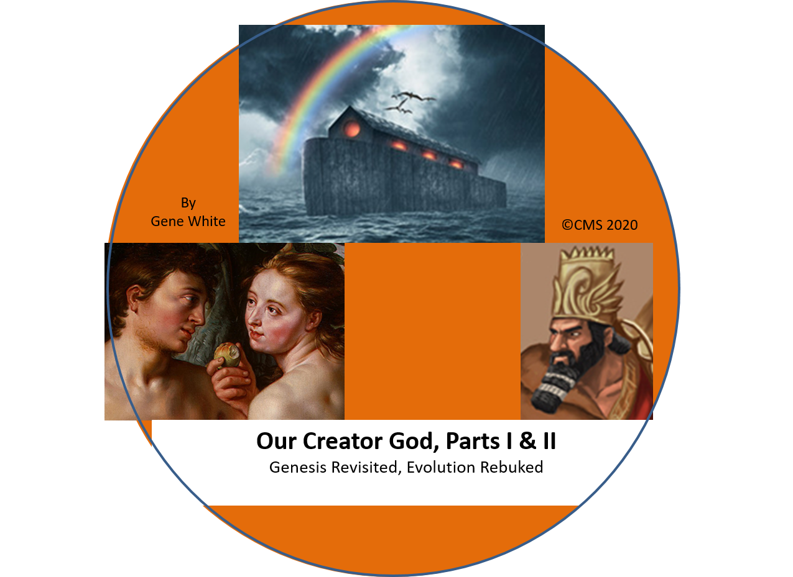
If you are unable to download the presentations or their companion demo presentations from the sound witness website contact churchmatter@frontier.com
Compiled and Designed by Gene White
© 2020CMS

Ordering and Cost: The basic CD can be ordered by email from churchmatters@frontier.com for free plus $10.00 S&H. Any additional titles Church Matters - Solutions can be included in your order for no additional cost...

